New Amazone Website
Amazone has fully revamped its on-line presence. The new website has been designed specifically from the customer's point of view and visitors are now greeted by a modern, user-friendly and clearly laid out Home page. The focal point of the new website is to meet the informational needs of customers, dealers and service staff. The clear structure of the website allows visitors to navigate quickly – for example, when searching for specific machines or specifications, or the latest company news from Amazone.
Information about new releases and special models can be found much quicker than before with just a few clicks. The wide-ranging contact information for dealers, and also the relevant contacts within Amazone, facilitates easy interaction.
The responsive, modern web design makes it more user-friendly on any device. Faster loading times enable easier access to website contents, such as SmartLearning or the on-line FertiliserService, either on the go via a mobile Internet connection, or in the field. In practice, this helps farmers or customer service engineers to acquire the information they need whilst with their machine in the field.
The detailed product pages now provide all the information about each machine at a glance and this includes videos and animations showing the machine in use, technical specifications, brochures, as well as instructions for installation and ensuring optimal operation after the machine’s arrival on farm.
Additional portals, such as the revised AMAZONE portal for sales partners or the comprehensive dealer locator, are connected to the website via special interfaces and so, thanks to the more integrated design, the new Amazone website now offers a holistic “one-stop shop” across all of its portals.
The Amazone website can be found at www.amazone.net. It’s well worth a visit!
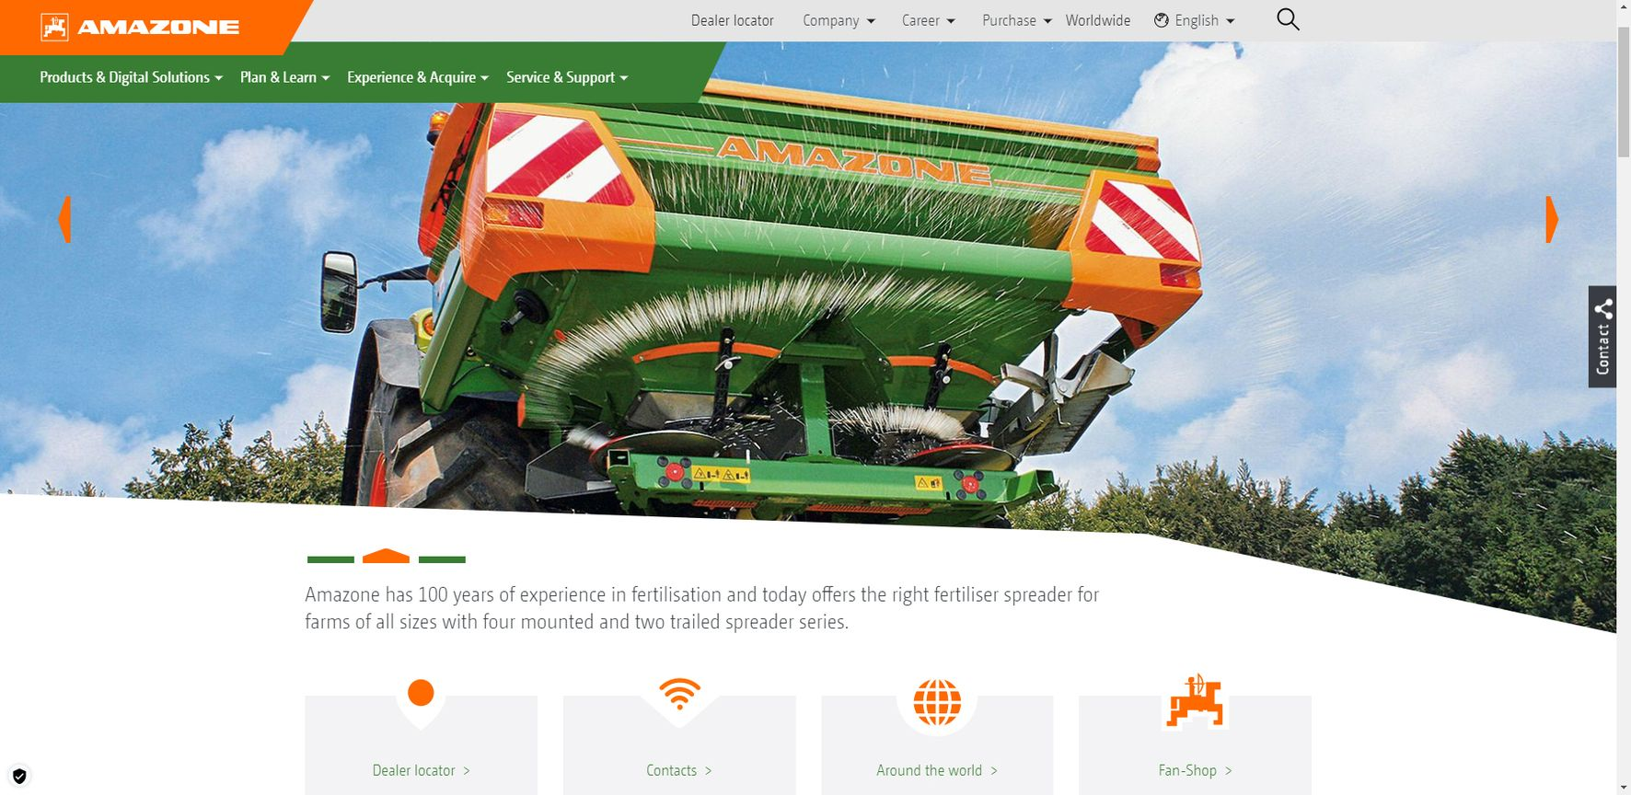
Picture: Amazone_website_home_en.jpg
The updated Amazone website provides quick access to all information and contacts

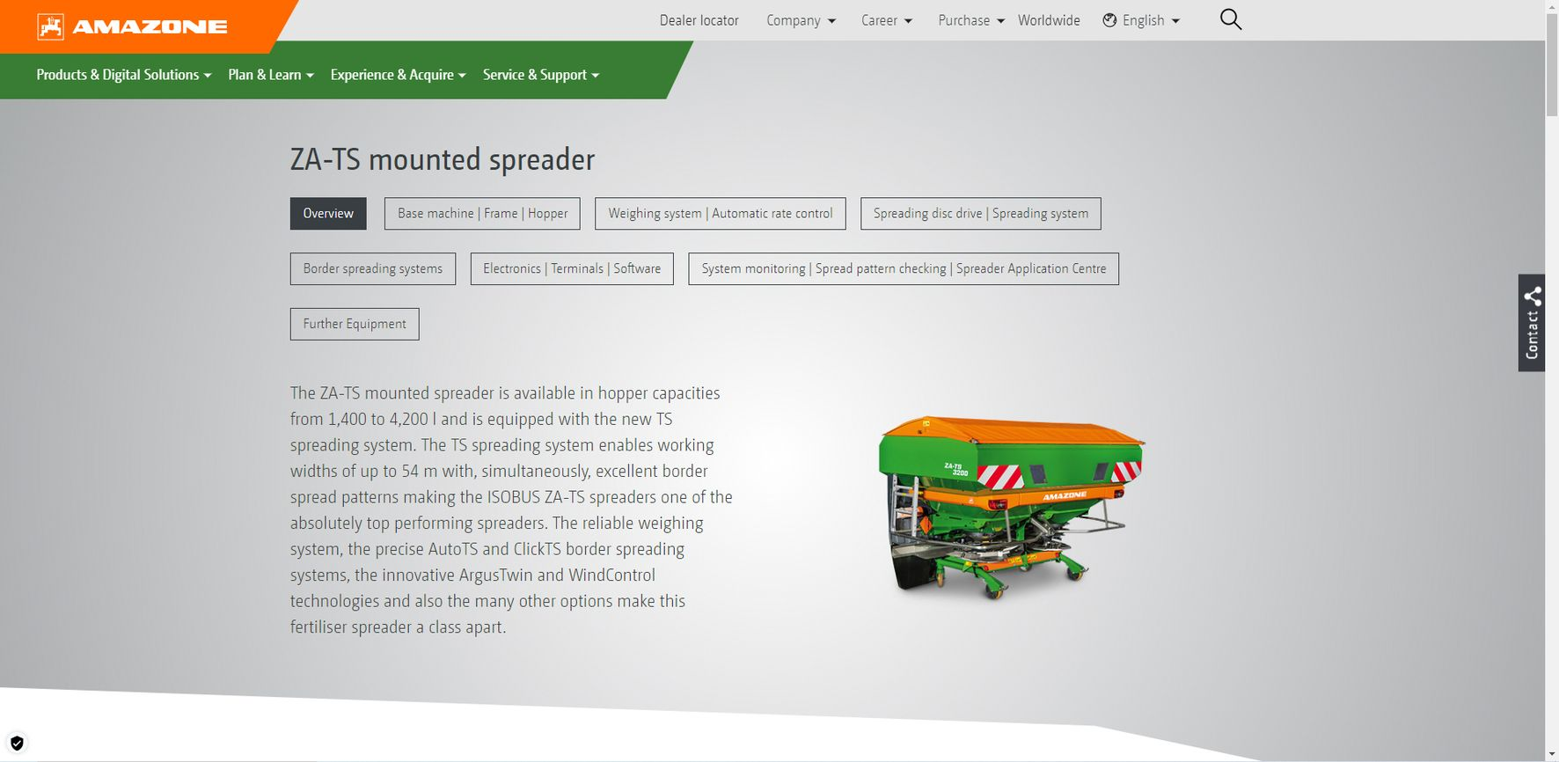
Picture: Amazone_website_products_en.jpg
All the information about Amazone machinery at a glance

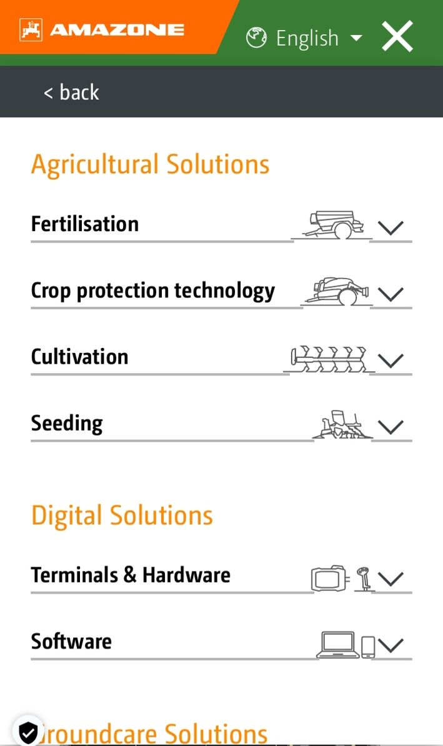
Picture: Amazone_website_mobile_navi_en.jpg
Responsive web design for improved readability on all devices

