**A successful start: New Global Parts Center sets the course for the future**

At the beginning of this year, Amazonen-Werke began commissioning the new spare parts centre at the Tecklenburg-Leeden plant. Amazone had set up a modern central spare parts store at the main factory in Hasbergen-Gaste more than 20 years ago. After several extensions and modernisation programmes over the last two decades, however, the capacity finally reached its limit due to the constant growth of the Group and the resulting increase in the volume of spare parts. This led to the decision to plan a completely new spare parts logistics system utilising existing buildings and areas at the Tecklenburg-Leeden facility.

The aim of the new logistics concept was to gain more storage capacity in the face of the increasing number of consignments and the need to build up stock while processing orders at an even faster rate and, at the same time, continuing to provide a reliable service. Amazone has achieved this by investing not only in cutting-edge warehouse and order picking technology but also in a completely new warehouse management system for more efficient handling of spare parts logistics.

Carolin Wiebusch-Rakonjac, Head of the Amazone Global Parts Center, sums up the key facts: "Going forwards, a considerably extended storage capacity with warehouse space of approximately 11,000 m² and outdoor space of 9,000 m² is available for more than 42,000 different spare parts. More than half of the items are held in an automatic small parts warehouse (ASPW) with approx. 27,000 bins and are automatically stored and retrieved with extremely high efficiency. The larger articles and higher quantities are efficiently managed manually in the newly designed narrow-aisle warehouse with space for approximately 12,500 skeleton containers with state-of-the-art order-picking stackers, as well as in the additional spacious area provided for the storage of long and bulky goods. Overall, this logistics concept will facilitate extremely efficient processing in the long term."

One of the most important innovations is that the orders are no longer processed in a linear fashion, i.e. step by step according to the storage area, but that all the items on an order are processed in parallel and later centrally combined in the packaging department. This has led to a significant improvement in throughput times. The spare parts logistics team of around 60 employees now process up to 1,000 packages per day for dispatch to Amazone customers.

Christian Dreyer and Dr. Justus Dreyer, the Managing Directors of Amazone, regard the latest investment as a customer- and future-oriented restructuring of the spare parts business: "The new Global Parts Center means that Amazone is ideally positioned to meet the increasing market requirements. The higher capacity and the modern fast warehouse and order picking processes guarantee a constantly high service level for our customers worldwide. The spacious warehouses and areas at the Leeden facility also offer a solid platform for the future expansion of individual storage areas".

**About AMAZONE**

AMAZONEN-WERKE H. Dreyer GmbH & Co.KG, based in Hasbergen-Gaste in Germany, manufactures agricultural and groundcare machinery. The owner-managed company employs around 1900 people at nine different production sites in Germany, France, Russia and Hungary. The agricultural machinery range includes soil tillage implements, seed drills, fertiliser spreaders and plant protection equipment.

Based on these core competencies, AMAZONE is now the specialist for intelligent crop production in agriculture.

Further information: [www.amazone.co.uk](http://www.amazone.co.uk)

[cid:FB_70d43fd1-a841-4de4-bbaa-3e1f495f95d3.jpg](https://www.facebook.com/amazone.group) [cid:IG_efb650a7-31e4-4674-98db-f2d2d5c58dce.jpg](https://instagram.com/amazone_group) [cid:YT_e9180d16-5a2b-4618-92e9-22a015f9cafb.jpg](https://www.youtube.com/user/amazonede) [cid:LinkedIn_80de4e9c-c7a3-41e3-8e11-063f7eace13d.jpg](https://www.linkedin.com/company/amazone-group/) [cid:Xing1_e3730686-2953-47a9-9c47-dbaa518a9207.jpg](https://www.xing.com/company/amazone)

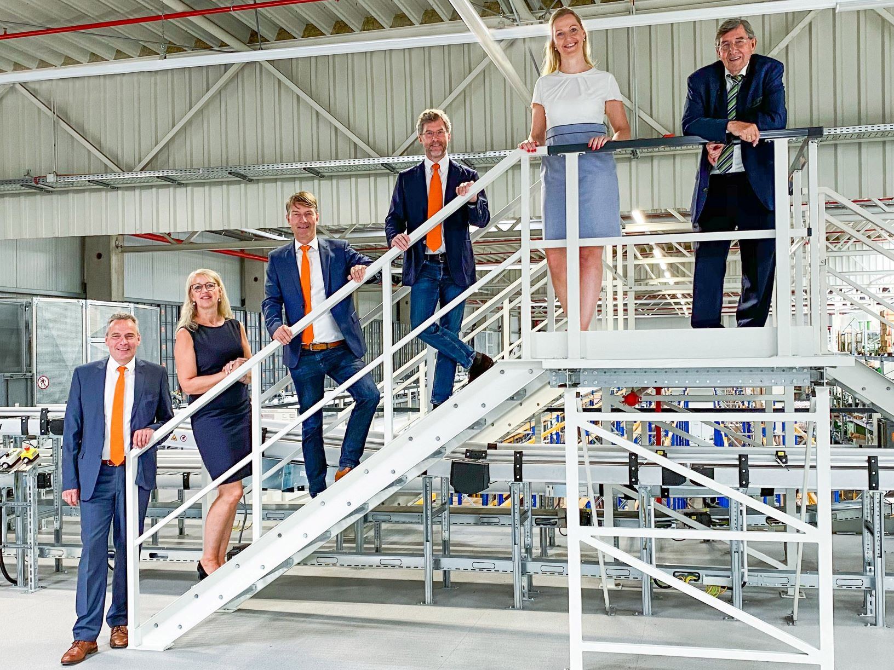

*Photo: Amazone\_GPC Leeden\_Geschäftsleitung.jpg*

The Amazone Management is impressed by the new warehouse and logistics facilities. From left to right: Andreas Hemeyer (Member of the Management for Sales and After Sales), Bettina Dreyer, Christian Dreyer and Dr. Justus Dreyer (Managing Directors of Amazone), Carolin Wiebusch-Rakonjac (Head of the Amazone Global Parts Center), Klaus Dreyer (Member of the Management)

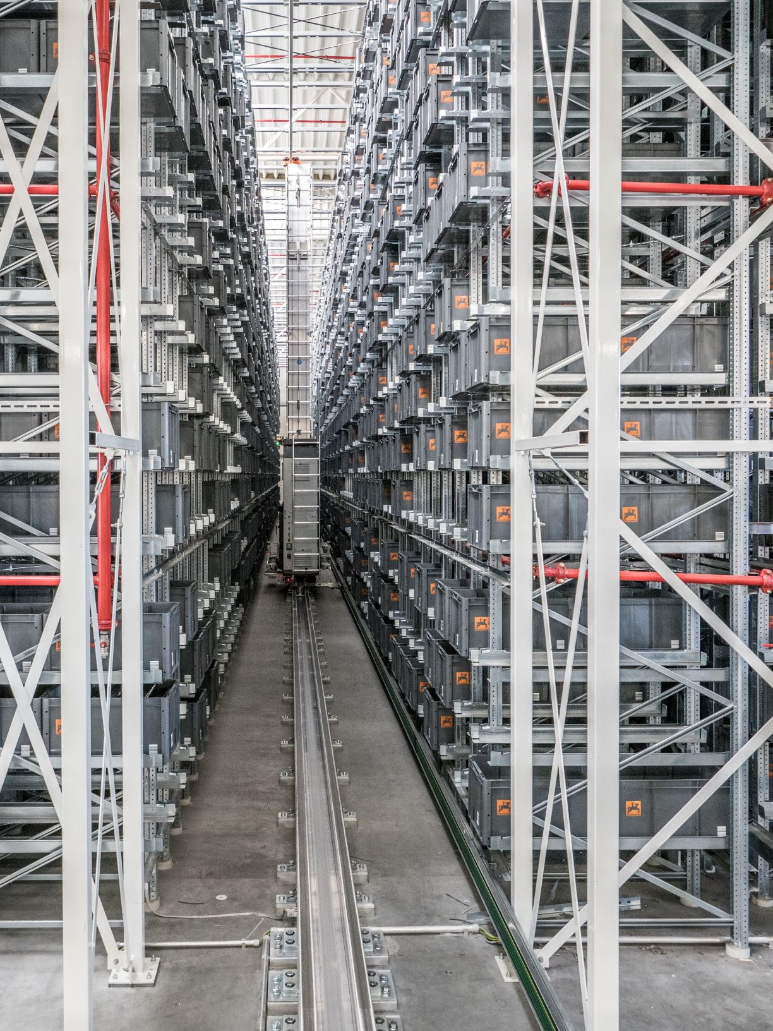

*Photo: Amazone\_GPC Leeden\_AKL.jpg*

Four high-performance stackers move goods in and out of stock from the 52 metre long aisles in the new automatic small parts warehouse (ASPW).

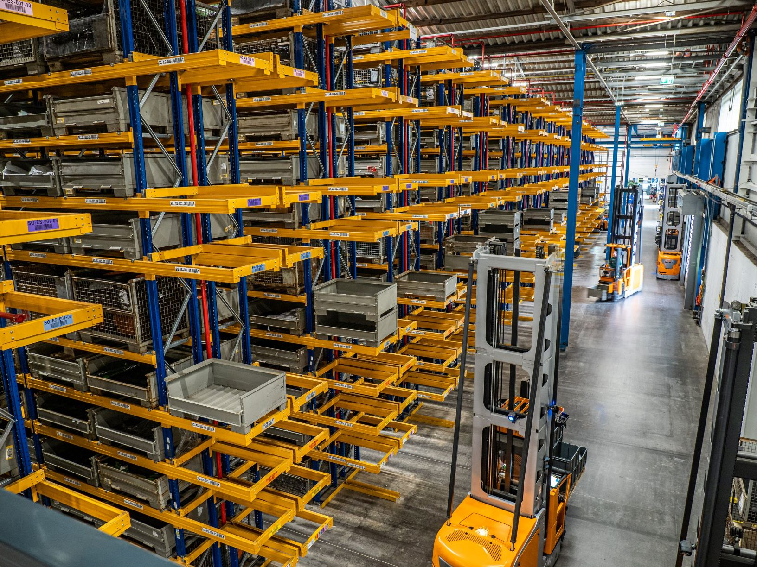

*Photo: Amazone\_GPC Leeden\_Schmalganglager.jpg*

The narrow-aisle warehouse comprises 33 rows of shelves, each with 10 levels and space for approx. 12,500 skeleton containers.

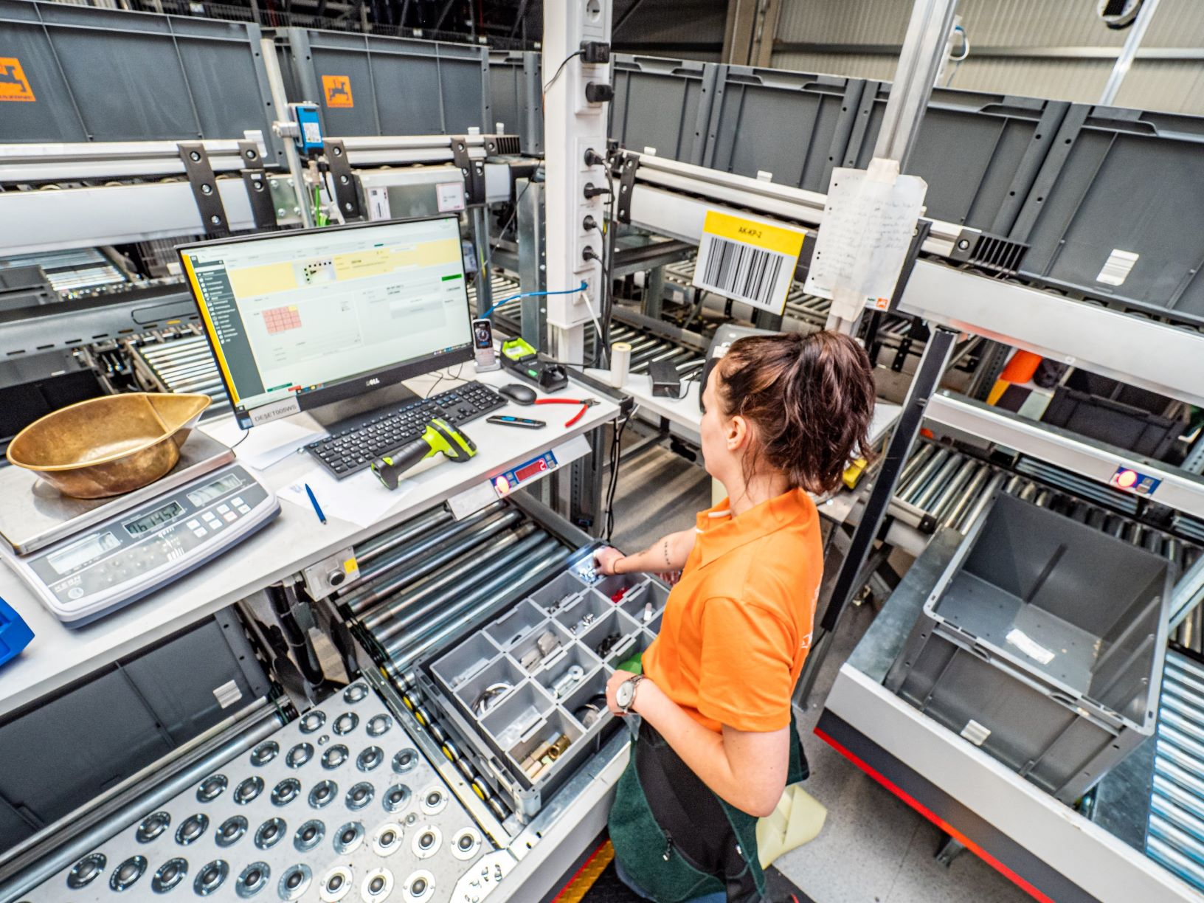

*Photo: Amazone\_GPC Leeden\_Arbeitsplatz.jpg*

Workstation with "Pick-by-Light picking"

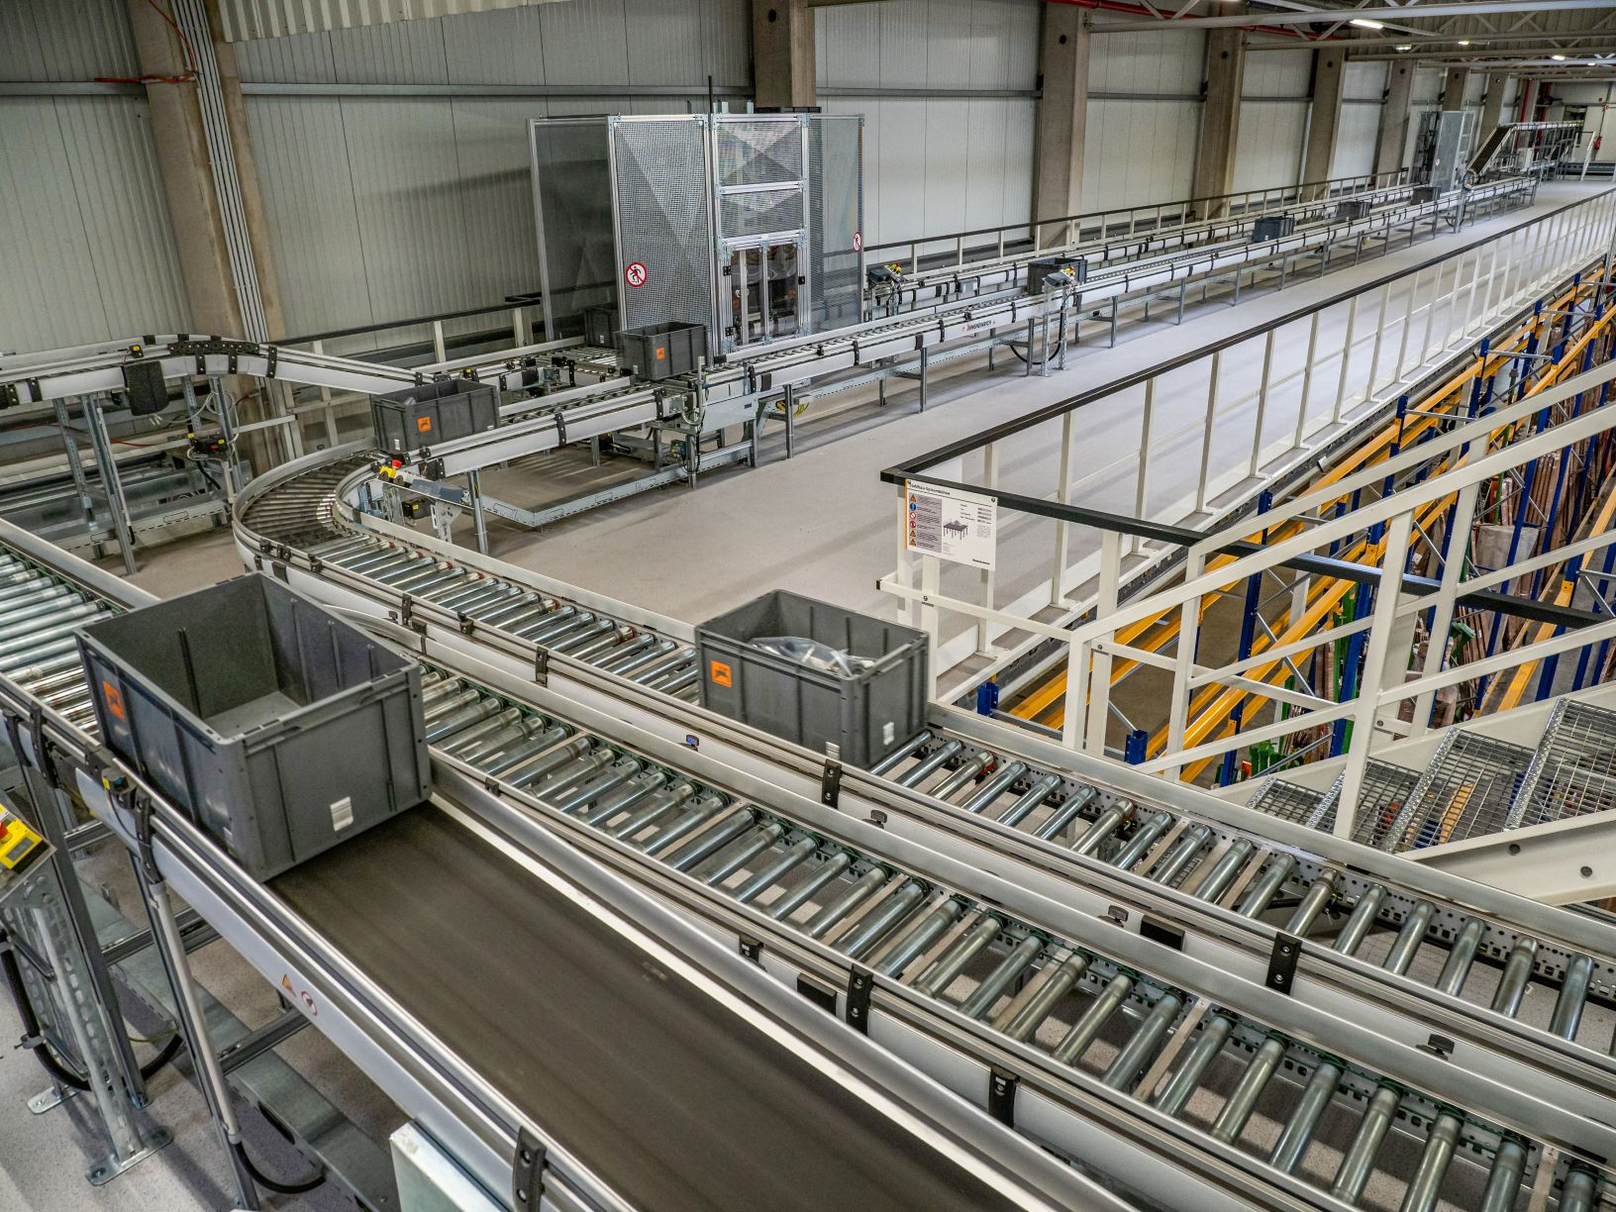

*Photo: Amazone\_GPC Leeden\_Fördertechnik.jpg*

The automatic small parts warehouse (AKL) is connected to goods in, picking and packing workstations via conveyor technology.